Stock Analysis

*Overview:*

Steve is looking to help his parent choose the correct stock to invest in. We use VBA in order to sort through the data by ticker to show total daily volume and return percentage for the years 2017 and 2018.

*Results:*

After running the Macro for the year 2018 we received the following results:

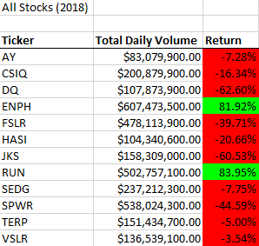

And For 2017 we received the following:

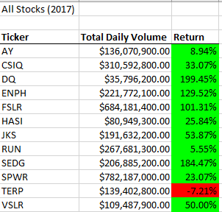

Based on the data we see that most of the stocks in 2017 had a positive rate of return compared to 2018 where most stocks where negative. The stocks for ENPH and RUN are the only stocks that were able to maintain a positive rate of return for both years. Out of those two stocks we see that ENPH was able to maintain it positive return in 2018 even though it we see the return was down over 40% from the 2017. On the other hand, RUN was able to increase it’s rate of return from just over 5% to over 80%. Looking at the data I would say that those two stocks would be the best to make an investment in.

We also tried refactoring the code to make it run smoother but for some reason it took longer to run the refactored code then it did for the original.

*Summary:*

Disadvantages:

* A long procedure may contain the same line of code in several locations, you can change the logic to eliminate the duplicate lines.
* A complex unstructured code is usually best to split in several functions.
* Refactoring process can affect the testing outcomes.

Advantages:

* Logical errors easily appear in well structure code that contains nested conditionals and loops.
* In our case, using Excel flow displays program logic in a more comprehensible manner, not tied to the order that the underlying code is written.
* VBA interpretation (Excel) of code can reveal patterns that are not easy to see in the source.